Thank you for joining the Alliance for Housing Solutions in asking Arlington County to allocate $25 million to the Affordable Housing Investment Fund in Fiscal Year 2021!

Instructions:
- Customize the letter, adding the date, your personal story or reasons why you support additional funding for AHIF, your name, and the name of the County Board member you are addressing the letter to.
- Print pages 2-3 double-sided.
- Fold the paper along the dotted lines with the address line facing out.
- Tape the flap and both sides closed.
- Add your return address and a stamp.
- Mail!

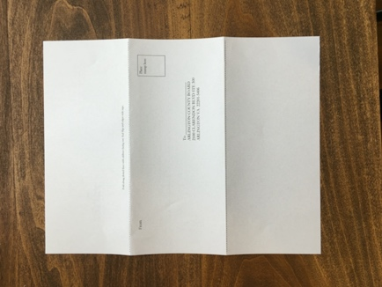

Arlington County Board Members
Libby Garvey, Chair
Erik Gutshall, Vice Chair
Matt de Ferranti, Member
Katie Cristol, Member
Christian Dorsey, Member

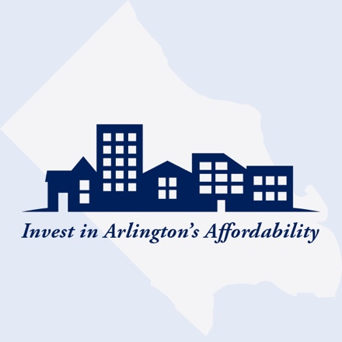
Arlington County Board
2100 Clarendon Blvd Ste 300
Arlington, VA 22201-5406

Date:

Dear __________________________,
I am writing to express my support for allocating $25 million to the Affordable Housing Investment Fund (AHIF) in Fiscal Year 2021.

I believe investing in Arlington’s affordability is important because
_____________________________________________________________________________
_____________________________________________________________________________
_____________________________________________________________________________.

Sincerely,

Fold along dotted lines with address facing out. Seal flap and edges with tape.

From
Place stamp here

To _________________________
ARLINGTON COUNTY BOARD
2100 CLARENDON BLVD STE 300
ARLINGTON VA 22201-5406

